Lloyd’s Capital Return 2026

MDC Development

Last updated: 09/June/2025
By: MRC | Predictive Analytics | Member Capital Team
Purpose: To summarise the changes being made to the 2026 LCR. Please review in conjunction with the 2026 annotated specification (Internal Model SCR - Lloyd's (lloyds.com) - Guidance Issued section) which has more detail on all the changes included.
Definitions

Term | Definition
Validation | A test which, when triggered, prohibits the user from submitting an LCR.
Warning | A test which, when triggered, requires the user to provide a comment prior to submitting an LCR.
Auto-calculated | A cell which does not require any manual input. It calculates a figure based on other cells in the LCR.
Pre-populated | A cell which does not require any manual input. It is pre-populated form another cell in the LCR.
Manual input | A cell which requires a manual input.
List of changes

Form 311
- New warnings
Net of reinsurance (Mean: cell A1, 99.5th: cell G1)
  - The warning is triggered if value of One-Year Basis Mean: Net of reinsurance (A1) is greater than Ultimate Basis Mean: Net of reinsurance (A3) minus Total Claims: Unincepted Legal Obligations as of December 2026, for the 2027 year of account (L2).
  - The warning is triggered if value of One-Year Basis 99.5th: Net of reinsurance (G1) is greater than Ultimate Basis 99.5^{th:} Net of reinsurance (G3) minus Total Claims: Unincepted Legal Obligations as of December 2026, for the 2027 year of account (L2).

Form 550
- Add wording
Question 1
  - Three new commentary lines appended in question 1.
- New warnings
LCR One-year Net Premium (cell G1)
  - The warning is triggered if value of LCR One-year Net Premium (G1) is greater than LCR Ultimate Net premium (A1).

Form 571
- Change formula
Question 1
  - In response to Question 1,
Q4 modelled: Management Adjustment is now added to Submitted SCR.
Ultimate: Risk Margin Adjustment (309.1 B3) is now added to Ultimate Syndicate SCR (309.1 B1)

Form 600
  - A whole new form is rebuilt to do the comparison between this return and previously created returns while selecting the return in Form 012 Dropdown in ‘Selected Return’ cell.

BAU annual changes

Annual Incremental Rollover of Year of Account

- Form 310
Increment new modelling year LCR added
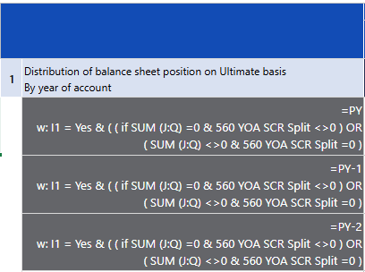

- Form 311
Increment new pure year for new modelling year LCR added.



- Form 312
New row added – table 1: columns A to Q
A straightforward replication of the last row of the table to present the new proposed year.

- Form 550
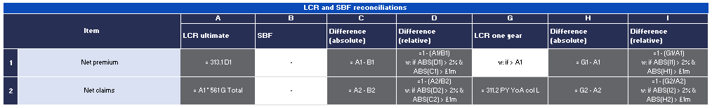
Increment new modelling year LCR - Ensure PY in formula is 2026 in response to Question 1, cell G2

- Form 560
Increment new modelling year LCR - Ensure: PY = 2026, PY-1 = 2025, PY-2 = 2024
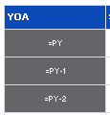

- Form 570
Increment new modelling year LCR - In response to Question 1 & 2, ensure: PY = 2026, PY-1 = 2025, PY-2 = 2024.
